

SIRSYED CASE INSTITUTE OF TECHNOLOGY
INFORMATION SECURITY
LAB # 12
NAME : LAIBAH RAUF
ROLL NO : 2430-0008
SUBMITTED TO : Ma’am Sadaf Ayub

Task 01:
Ping:
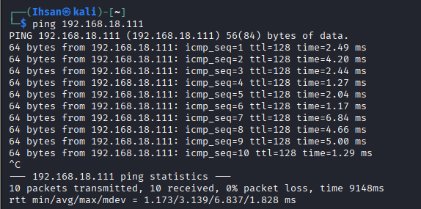
Nmap:
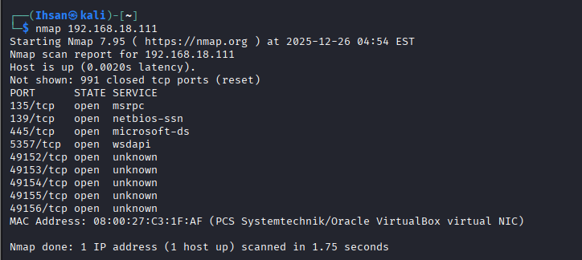
Hping3:
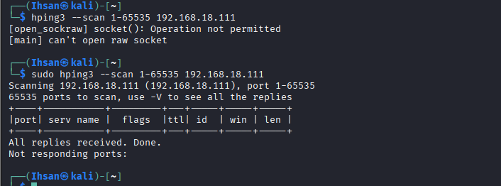
Sudo hping3 -s:
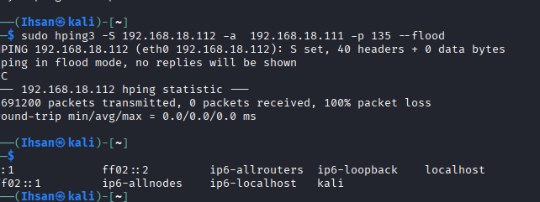
Ddos Attack:
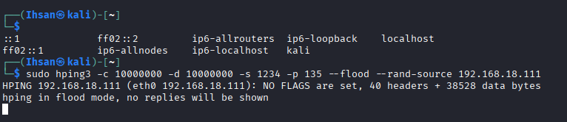
Wireshark:
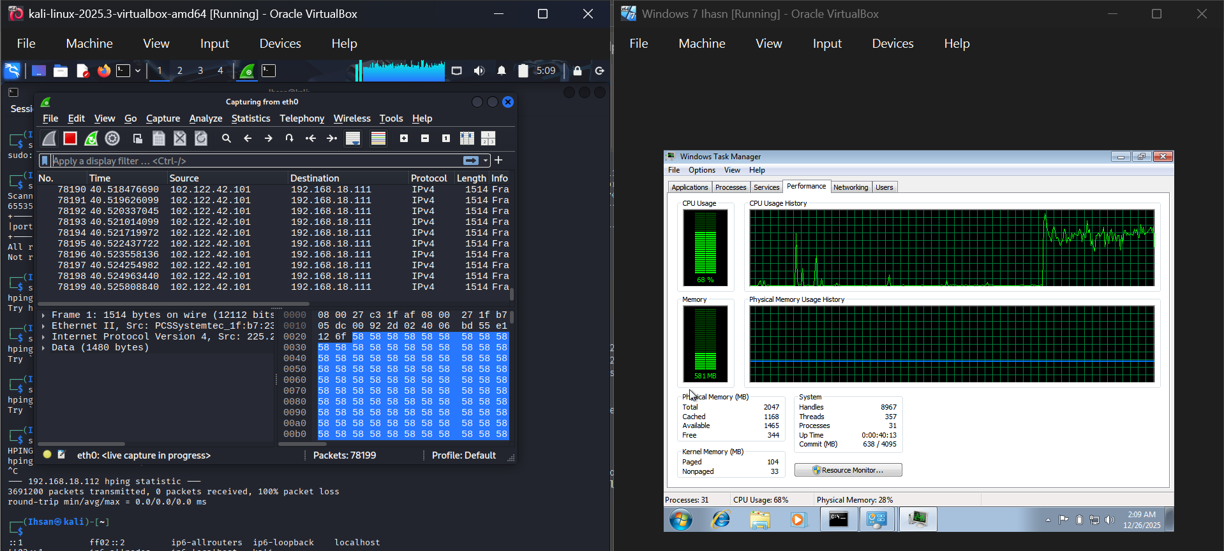
Processor Performance :
